Self Service Desktops Concept Specification

|  |  |  |
| --- | --- | --- |
| Author | Date | Notes |
| Simon Waterhouse | 10 May 2013 | Initial version |
|  |  |  |

Contents

Introduction 2

Objectives 2

High Level Use Case 2

Operation Overview 2

Solution Roles 3

Administrator 3

End User 3

Desktop Offerings 3

Self Service Web App 4

Self Service Desktops Agent 5

Deployment Options 6

Merlin Migration Strategy 6

Outstanding Work 6

# Introduction

This document describes the Citrix Self Service Desktop solution.

# Objectives

Citrix CloudPlatform is a comprehensive infrastructure as a service cloud management solution which includes self-service capabilities. Many customers want to leverage self-service functionality for their virtual desktop installations to provide a portal where the user can select the desktop flavor he requires. In addition it should give the users more control over their desktops like start, stop, reboot, console access, network attach, attach ISO, attach volumes, console access and more. At the same time the performance to access the desktop should be optimal – hence XenDesktop with HDX capabilities should be used.

This document describes how Citrix CloudPlatform can be integrated with XenDesktop by a simple product named Citrix Self Service Desktops to provide this functionality.

# High Level Use Case

The solution is targetted at Enterprise Customers who ask for developer desktops (don‘t see primary use case for service providers)

The Enterprise users (e.g. developers) subscribe to desktops using the Self Service Web App, are able to create and delete desktops on demand, power manage the desktops and access the desktop through the XenDesktop Web Interface.

# Operation Overview

The diagram below illustrates the overall architecture of the solution.

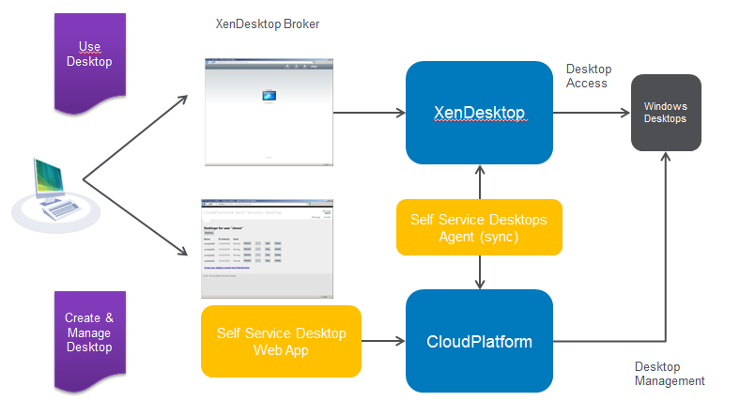

A standard Citrix CloudPlatform is used to host the self-service user desktops. The first component of the solution is a simple Self Service Desktop Web Application that is provided to allow users to create, delete and power manage desktops; this makes use of the standard CloudPlatform API to manipulate the desktop virtual machines in CloudPlatform.

As stated above, the goal of the solution is to allow the end user to access his or her desktop using optimised Citrix HDX technology. To this end, the second component of the solution is the Citrix Self Service Desktop Agent (sometimes also referred to as the “sync script”). This is a Windows Service that publishes the desktops created in CloudPlatform to the XenDesktop broker so that the end use can access the desktops via the XenDesktop Web Interface console.

The Citrix Self Service Desktop Agent will ensure newly created desktops are registered with the XenDesktop broker, and also de-register any desktops that are deleted in CloudPlatform.

# Solution Roles

The solution assumes two roles:

## Administrator

The Administrator installs and configures the components of the solution. As the solution synchronizes between CloudPlatfrom and XenDesktop, it is recommended that this role is also a CloudPlatform and XenDesktop administrator.

## End User

The end user of the solution is typically a developer who wishes to create, delete and power manage desktops on demand.

# Desktop Offerings

A key concept of the solution is that of desktop offering. The Administrator configures one or more desktop offerings that define the desktop types that an end user may create.

Desktop offerings have the following attributes:

* Offering Name
* Description
* CloudPlatform Zone
* CloudPlatform Template
* CloudPlatform Service Offering
* CloudPlatform Network
* Host name prefix

An example desktop offering configuration element may look like this

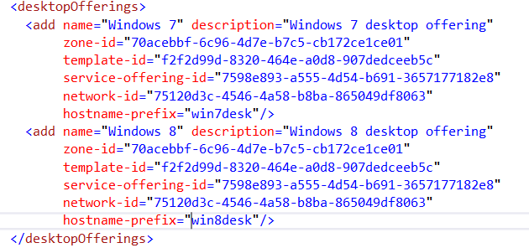

The host name prefix is used to generate desktop names. As users create desktops from an offering, an incrementing number will be appended to the prefix to create a unique name (e.g. win7desk001, win7desk002 etc.). This is the name that will be displayed in the CloudPlatform administration UI and also the name that will be allocated for the new desktop both in Active Directory and XenDesktop.

# Self Service Web App

The Self Service Web App is very simple: there is one screen to allow an end user to create a desktop as illustrated below

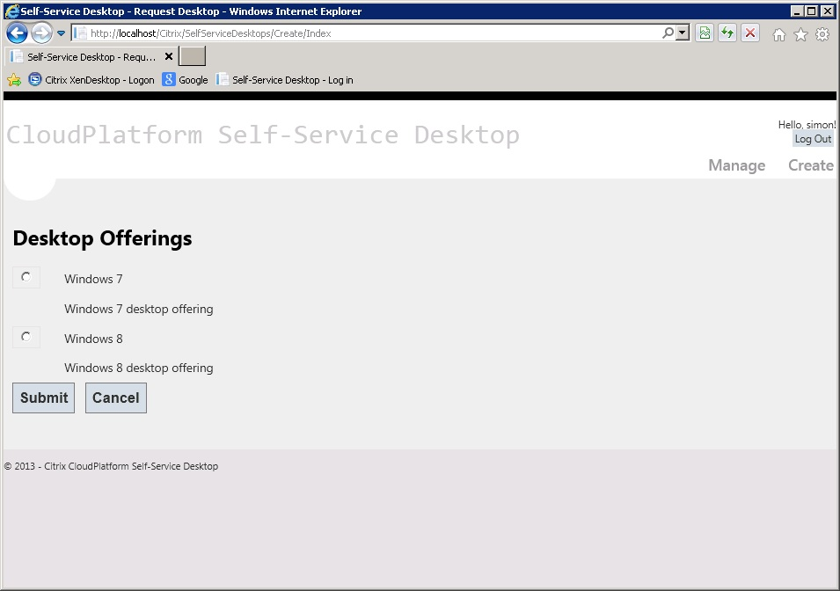

There is also a screen to allow the end user to manage the desktops he or she has created:

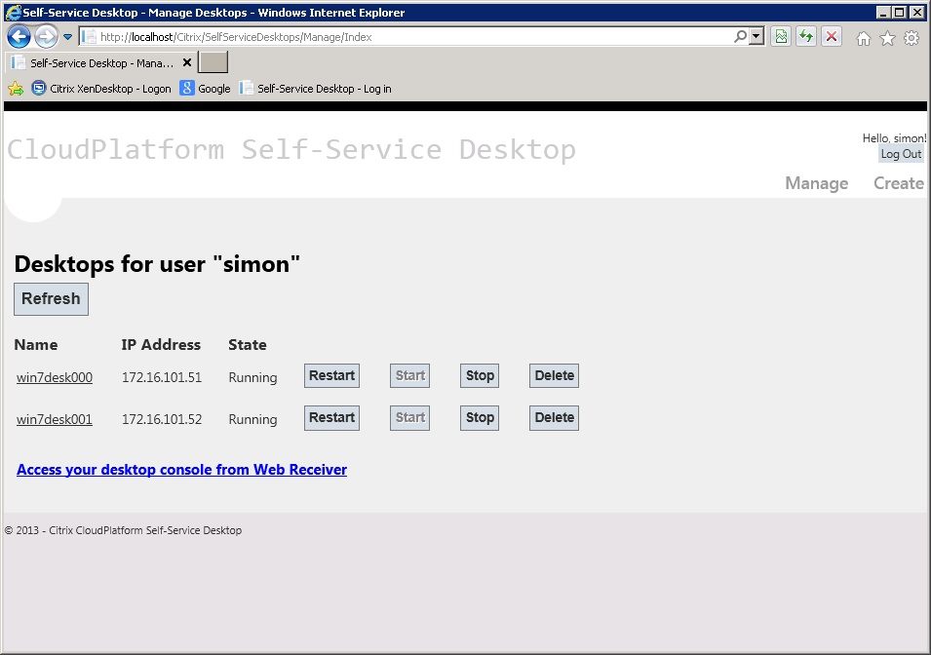

# Self Service Desktops Agent

The Self Service Desktop Agent is a Windows Service that runs in the background synchronizing dekstops between the CloudPlatform and XenDesktop environments.

As it is registering and de-registering machines with the XenDesktop Broker it need to run under a XenDesktop Administrator account. The Windows Installer for this component will prompt for Administrator credentials at install time.

The Self Service Desktop Agent Windows Service performs two roles:

1. It acts as a configuration server, so that the Administrator need only define the desktop offerings in one place. The configuration is readable as an Xml document via a simple REST Url (e.g. http://<my-server>:8000/config) and is read by the Web App.
2. It schedules a “sync script” to be run at regular intervals (every 30 seconds is the default). The script will (for each desktop offering)
   1. Enumerate the virtual machines in CloudPlatform, identifying those that are Self service desktops by search for thos whose names match a specified pattern (hostname prefix followed by a number)
   2. Enumerate the desktops published in a specific XenDesktop catalog
   3. Each desktop that is in CloudPlatform but not in XenDesktop is registered in XenDesktops and published for its owner
   4. Each desktop that is in the XenDesktop catalog but not in CloudPlatform is de-registered from XenDesktop

# Deployment Options

Both the Self Service Web App and the Self Service Agent are Windows applications that should be installed on Windows Server 2008 or Windows Server 2008 R2.

For a simple proof of concept deployments both the web app and agent may be installed on the XenDesktop controller.

For larger multi-XenDesktop Controller deployments the Self Service Desktop Agent may be deployed on each of the XenDesktop Controllers, and the configuration of each Agent edited to ensure each Self Service Desktop Agent is servicing an appropriate proportion of the overall system [mechanism TBD]

If required the web app can be installed on a different server, and either provided with its own configuration (in the local Web.config file) or pointed to one of the XenDesktop controllers to retrieve shared configuration from one of the Agents.

# Merlin Migration Strategy

[TBD]